**Breathing rate and exercise – Validation Test - Enrichment**

**Marks Available: /??**

1. What variable were you measuring (dependent variable)? (1 mark)

___________________________________________________________________________

1. Give two variables that you kept the same during this experiment. (2 marks)

______________________________________________________________________________________________________________________________________________________

1. Below are two safety precautions you would have talked about in your investigation. Describe how you would make sure these things don’t happen. (2 marks)

|  |  |
| --- | --- |
| Safety issue | How did you make sure this didn’t happen? |
| 1. Falling over and hurting yourself while exercising. |  |
| 1. Passing out while exercising because you haven’t eaten breakfast. |  |

A student conducted a similar investigation. They looked at their heart rates (beats per minute, bpm) after exercising. Unfortunately, they did not understand the value of a good data table, and so they recorded their data below.

*Just before going for a run, two students measured their resting heart rate. Student A recorded a heart rate of 57 bpm while Student B recorded a heart rate of 58 bpm.*

*After the run, for the 1st reading, Subject A was at 100bpm, Student B was recorded 95 bpm.*

*The next time they checked their heart rate, both students recorded 82 bpm.*

*They recorded their heart rate every minute for 10 minutes after going for a run.*

*At 5 minutes, they both had a heart rate of 60 bpm.*

*Their heart rate did not change after 5 minutes.*

*Minute 4 = Student A was 64, B = 65*

*Student A = 68, Student B = 70 at 3 minutes*

1. Complete the table below to display this information. (2 marks)

|  |  |  |  |  |  |  |  |  |  |  |  |  |
| --- | --- | --- | --- | --- | --- | --- | --- | --- | --- | --- | --- | --- |
|  | Heart rate recorded each minute (BPM) | | | | | | | | | | | |
|  | At rest | 0  mins | 1  mins | 2  mins | 3  mins | 4  mins | 5  mins | 6  mins | 7  mins | 8  mins | 9  mins | 10  mins |
| Student A |  |  |  |  |  |  |  |  |  |  |  |  |
| Student B |  |  |  |  |  |  |  |  |  |  |  |  |

1. On the grid below, draw a **line** graph using Student A’s data from Question 4 on the grid below. (3 marks)

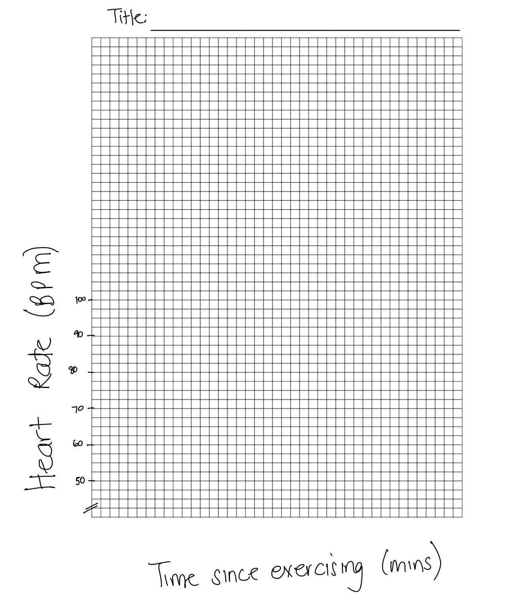

1. Looking at the graph you have drawn, complete the following statements. (3 marks)

After exercising the breathing rate went _________________________________________.

This is shown at minute 1 because the breathing rate was __________________________.

At minute 10 the breathing rate was ___________________________________________.

1. During your experiment, you would have been asked to calculate an average breathing rate. Find the average of the numbers given below. Show your working. (2 marks)

17 15 18 15 13 15 18 17

1. The experiment in this test recorded an increase in heart rate. What caused the heart rate to go up? (3 marks)

Use the words below to help you answer the question.

Heart Blood Oxygen Energy Carbon dioxide Lungs

______________________________________________________________________________________________________________________________________________________

______________________________________________________________________________________________________________________________________________________

______________________________________________________________________________________________________________________________________________________

______________________________________________________________________________________________________________________________________________________

1. In the experiment you completed in class, what happened to your breathing rate after you did some exercise? Explain why you think this happened. (3 marks)

______________________________________________________________________________________________________________________________________________________

______________________________________________________________________________________________________________________________________________________

______________________________________________________________________________________________________________________________________________________

______________________________________________________________________________________________________________________________________________________

______________________________________________________________________________________________________________________________________________________

______________________________________________________________________________________________________________________________________________________

1. Label the diagram below of the heart. (9 marks)

